SIMATS ENGINEERING
ASSESSMENT TOOL 1: Simulation Task

COURSE NAME: Embedded Systems
COURSE CODE: ECA1421

COURSE OUTCOME COVERED

CO2: Apply Embedded C programming concepts, including structured design, real-time constraint handling, and System C-based modelling, to develop and analyze embedded applications for industrial use cases. (BL5)

Name of the Student: Mano Prashanth R
Register Number :192412601

Construct a simulated Embedded C program for a smart energy meter with data transmission.
Requirements Analysis &  Conceptual  Understanding (20) | System Design &  Simulation Model  Development  (25) | Implementation &Tool Usage (20) | Testing,  Validation  & Result  Analysis  (20) | Documentat  Ion (15) | Total  (100)

Code of Conduct:
I Mano Prashanth R (192412601) certify that this submission is my original work and that I have adhered to the guidelines specified for this assessment. I understand that any violation of academic integrity rules will result in disciplinary action.

Signature of the student: Mano Prashanth R

Construct a simulated Embedded C program for a smart energy meter with data transmission.
Aim
To design and simulate a Smart Energy Meter with data transmission using Embedded C programming in Keil μ Vision for monitoring energy consumption and transmitting the measured data through UART communication.
Objective
- To simulate the operation of a Smart Energy Meter using Embedded C.
- To implement UART communication for transmitting energy readings.
- To verify the program using the Keil μ Vision simulator.
- To understand the application of embedded systems in smart energy monitoring.

Introduction
- A Smart Energy Meter is an embedded system designed to monitor and record electrical energy consumption. Unlike conventional meters, a smart energy meter can transmit consumption data automatically, eliminating the need for manual meter readings. These meters improve billing accuracy, reduce human intervention, and enable real-time monitoring of electricity usage.

- In this simulation, the AT89C51 microcontroller is programmed using Embedded C to simulate energy consumption. The energy value is periodically updated and transmitted through the UART interface. The simulation is performed in Keil μVision, where the UART window is used to observe the transmitted energy readings.

- This project demonstrates the basic concepts of embedded programming, serial communication, and system simulation, which are widely used in industrial energy monitoring applications.

Requirements Analysis
The Smart Energy Meter is designed to monitor and transmit energy consumption data using an embedded system. The simulation focuses on implementing energy calculation and UART-based data transmission using the AT89C51 microcontroller in Keil μVision. The system should execute continuously, provide reliable serial communication, and allow easy verification through the simulator.
Functional Requirements
- Simulate energy consumption by updating the energy value.
- Calculate the total energy units consumed.
- Transmit energy readings through UART.
- Execute continuously without interruption.
Non-Functional Requirements
- Low memory and processor utilization.
- Reliable UART communication.
- Easy simulation and debugging in Keil μVision.
Software and Hardware Requirements
Component | Specification
IDE | Keil μVision 5
Programming Language | Embedded C
Microcontroller | AT89C51
Crystal Frequency | 11.0592 MHz
Communication | UART (Serial Port)
Hardware Requirements (Theoretical)
- AT89C51 Microcontroller
- Crystal Oscillator (11.0592 MHz)
- UART Communication Interface
System Design
Block Diagram

Working Principle
The Embedded C program initializes the UART module and starts the simulation. The energy value is increased periodically to represent energy consumption. After each update, the current energy value is transmitted through the UART interface. The Keil Serial Window receives and displays the transmitted readings continuously. This process repeats indefinitely, simulating the operation of a smart energy meter.
Algorithm
- Start the program.
- Initialize UART communication.
- Initialize the energy variable.
- Increase the energy value periodically.
- Convert the energy value into ASCII format.
- Transmit the value through UART.
- Introduce a delay.
- Repeat the above steps continuously.

Program Flowchart

Embedded C Program
#include <reg51.h>
unsigned int energy = 0;
/* Delay Function */
void delay(void)
{ unsigned int i, j;
for(i = 0; i < 500; i++)
{
for(j = 0; j < 1275; j++);
}}
/* UART Initialization */
void UART_Init(void)
{
TMOD = 0x20; // Timer1 Mode 2 (Auto Reload)
TH1 = 0xFD; // 9600 Baud Rate @11.0592 MHz
SCON = 0x50; // UART Mode 1, REN Enabled
TR1 = 1; // Start Timer1
TI = 1; // UART Ready}
/* Transmit One Character */
void UART_TxChar(char ch)
{
SBUF = ch;
while(TI == 0);
TI = 0;
}
/* Transmit String */
void UART_TxString(char *str)
{ while(*str)
{
UART_TxChar(*str);
str++;
}
}
/* Transmit Number */
void UART_TxNumber(unsigned int num)
{
char buffer[6];
char i = 0;
if(num == 0)
{ UART_TxChar('0');
return;
}
while(num > 0)
{
buffer[i++] = (num % 10) + '0';
num = num / 10;
}
while(i > 0)
{
UART_TxChar(buffer[--i]); }
}
/* Main Program */
void main(void)
{
UART_Init();
UART_TxString("SMART ENERGY METER");
UART_TxChar('\r');
UART_TxChar('\n');
UART_TxChar('\r');
UART_TxChar('\n');
while(1){
energy = energy + 5; // Simulated Energy Consumption
UART_TxString("Energy = ");
UART_TxNumber(energy);
UART_TxString(" Units");
UART_TxChar('\r');
UART_TxChar('\n');
delay();
}
}
Program Explanation
The program begins by including the reg51.h header file required for the AT89C51 microcontroller. A global variable named energy is declared to store the simulated energy value.
The UART_Init() function configures the serial communication by setting Timer 1 in auto-reload mode and selecting a baud rate of 9600 bps. The UART_TxChar() function transmits a single character through the UART, while UART_TxString() sends an entire string. The UART_TxNumber() function converts the numerical energy value into ASCII characters before transmission.
Inside the main() function, the UART is initialized, and the energy value is increased by five units during each iteration. The updated value is then transmitted through the UART interface. A delay is introduced before repeating the process, producing continuous energy readings in the Serial Window.
Simulation and Testing
Simulation Procedure
- Created a new project in Keil μVision.
- Selected the AT89C51 microcontroller.
- Added the Embedded C source file.
- Compiled the program successfully.
- Entered Debug Mode.
- Opened the UART Serial Window.
- Executed the simulation.
- Verified the transmitted energy readings.
Simulation Output
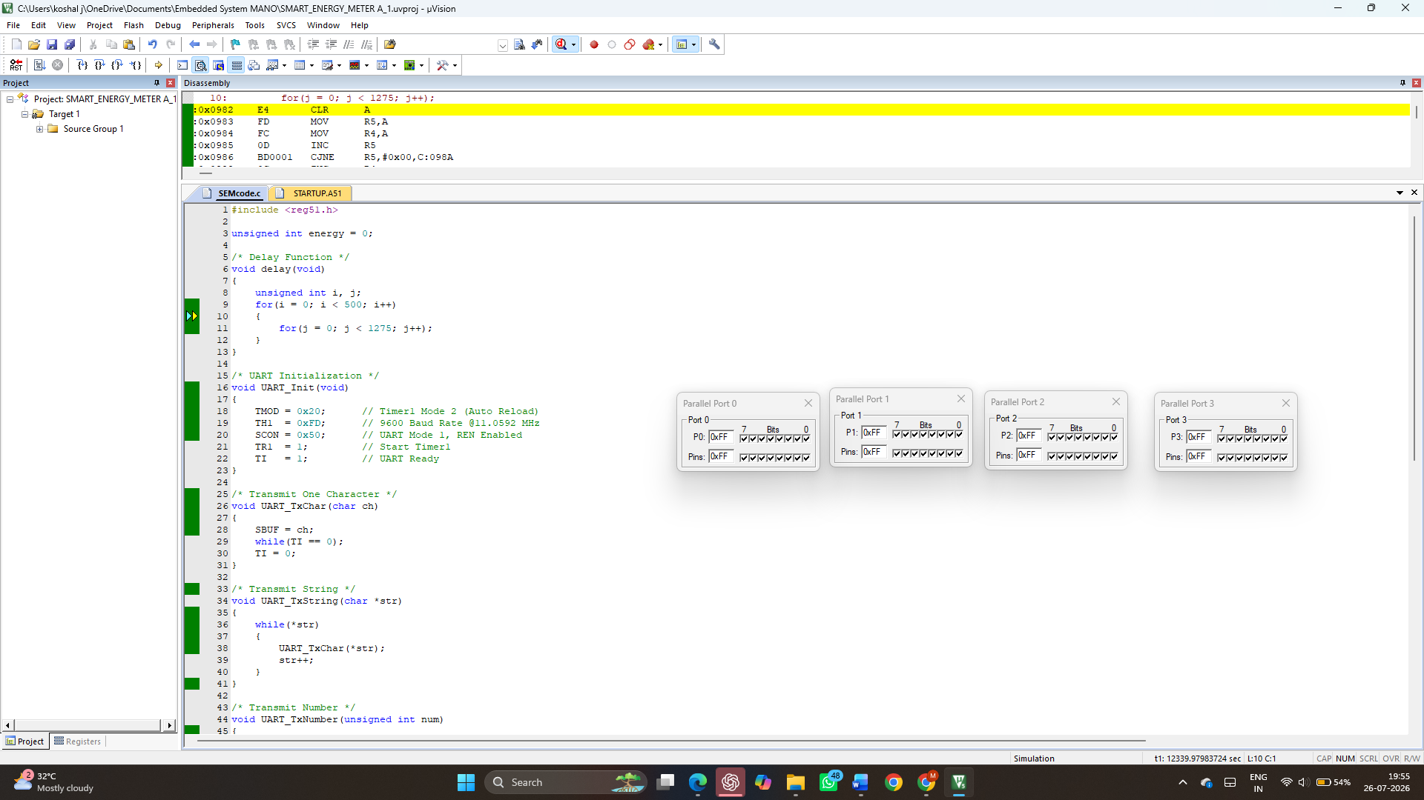
Figure 1. Embedded C Program for Smart Energy Meter.

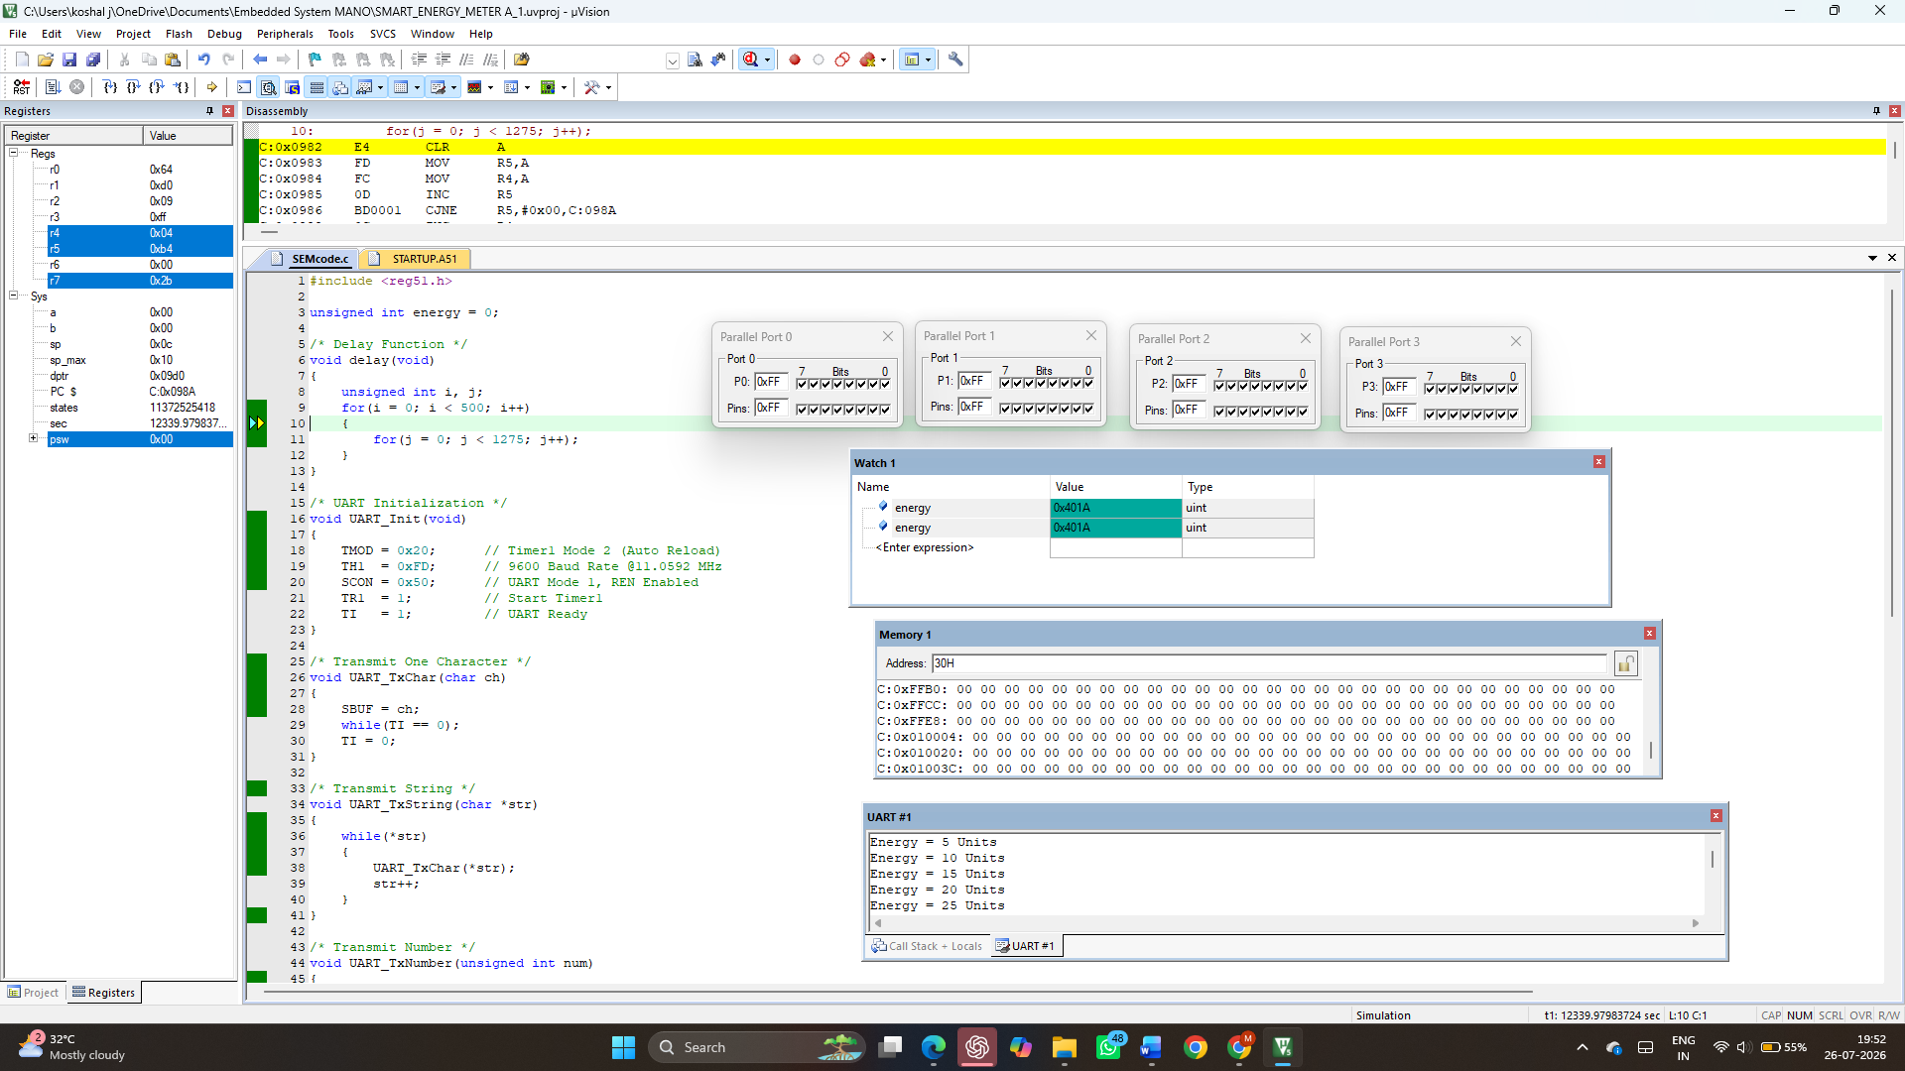
Figure 2. Simulation of Smart Energy Meter in Keil μVision.
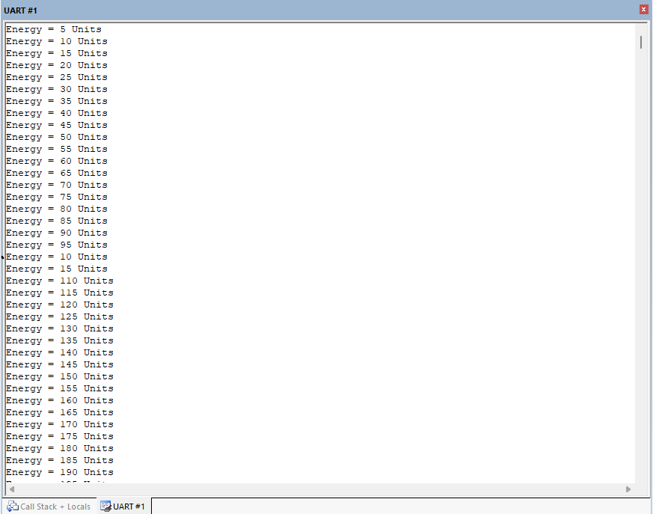
Figure 3. UART Data Transmission Output.

Result Analysis
The Smart Energy Meter simulation executed successfully in Keil μVision. The UART module transmitted the simulated energy readings continuously, confirming correct implementation of serial communication. The energy value increased as expected, demonstrating proper execution of the Embedded C program. The simulation verified the functionality of the smart energy meter without requiring external hardware.
Advantages
- Simple and efficient Embedded C implementation.
- Reliable UART communication.
- Easy debugging using Keil μVision.
- Low memory requirements.
Applications
- Smart electricity meters
- Residential energy monitoring
- Industrial power monitoring
- Automated billing systems
- Energy management systems
Future Enhancements
- LCD display integration.
- GSM or Wi-Fi communication.
- IoT cloud connectivity.
- Automatic electricity bill calculation.
- Real-time sensor integration.
Conclusion
The Smart Energy Meter with data transmission was successfully simulated using Embedded C in Keil μVision. The program accurately simulated energy consumption and transmitted the readings through UART communication. The project demonstrates the application of embedded systems in smart energy monitoring and highlights the effectiveness of Keil μVision for developing and testing embedded applications.

